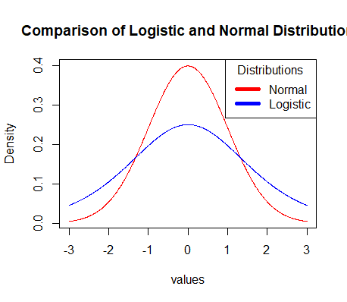

4. We would see more samples with extreme values in the logistic distribution. The normal curve has the majority of values in the middle while the logistic is more spread out so you would expect to see more extreme values out of the logistic distribution.

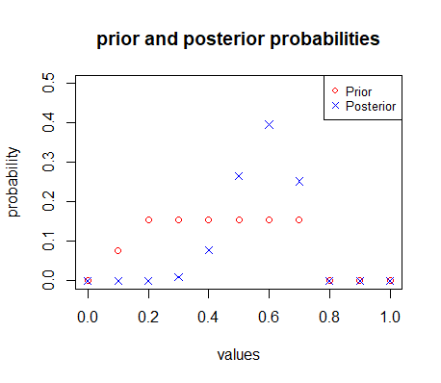

5.a.

priorvalues priorprob posteriorprob

[1,] 0.0 0.00000000 0.000000e+00

[2,] 0.1 0.07692308 5.976231e-08

[3,] 0.2 0.15384615 1.908083e-04

[4,] 0.3 0.15384615 8.506613e-03

[5,] 0.4 0.15384615 7.824331e-02

[6,] 0.5 0.15384615 2.647996e-01

[7,] 0.6 0.15384615 3.961067e-01

[8,] 0.7 0.15384615 2.521528e-01

[9,] 0.8 0.00000000 0.000000e+00

[10,] 0.9 0.00000000 0.000000e+00

[11,] 1.0 0.00000000 0.000000e+00

b.

priorvalues priorprob posteriorprob

[1,] 0.0 0.00000000 0.0000000000

[2,] 0.1 0.07692308 0.0003273741

[3,] 0.2 0.15384615 0.0116268399

[4,] 0.3 0.15384615 0.0679281068

[5,] 0.4 0.15384615 0.1765826304

[6,] 0.5 0.15384615 0.2707084609

[7,] 0.6 0.15384615 0.2648739457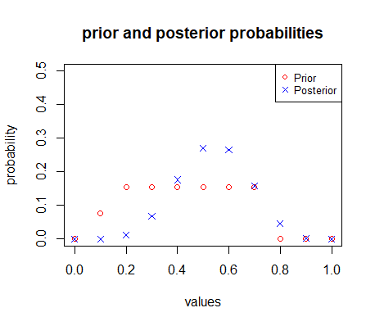

[8,] 0.7 0.15384615 0.1584989158

[9,] 0.8 0.00000000 0.0465073595

[10,] 0.9 0.00000000 0.0029463670

[11,] 1.0 0.00000000 0.0000000000

The sequential update probabilities are different.

c. Sequential update does not make sense in this case because of the lack of knowledge about the new sample. We don’t know if the sample was taken properly and as a result, we don’t want to update our posterior using data that is potentially wrong. However, frequentist methods would be affected less because bad data will be “drowned” out in a sense.